MACHINE LEARNING PROJECT
PROJECT: CUSTOMER SEGMENTATION USING K-MEANS CLUSTERING

PROBLEM STATEMENT:
A prominent retail mall seeks to gain deeper insights into its diverse customer base to enhance customer understanding and improve targeted business strategies. As a data scientist, the primary objective is to segment the mall's customers into distinct groups based on their behavioural patterns, specifically utilising metrics such as annual income and spending score to understand their behaviour and inform targeted business strategies, such as personalised offers.

WORK FLOW:
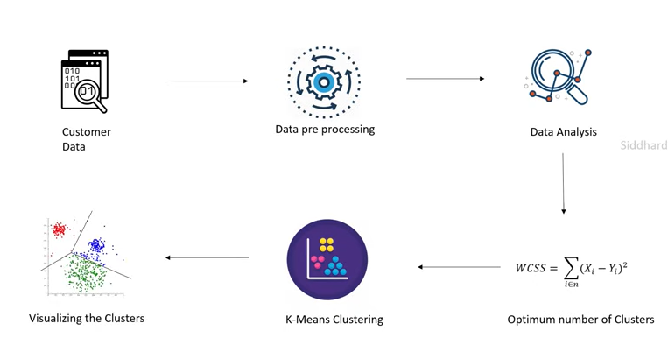

1. Customer Data
- Dataset: Mall_Customers.csv
- Contains fields like CustomerID, Gender, Age, Annual Income (k$), Spending Score (1–100).
- Problem Statement: Segment customers based on Annual Income and Spending Score to understand shopping behavior.

2. Importing the dependencies:

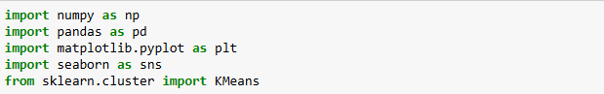

- NumPy was used for numerical computations and array operations.
- Pandas was used for data loading, manipulation, and analysis.
- Matplotlib and Seaborn were used for data visualization and plotting graphs.
- KMeans from scikit-learn was used to implement the K-Means clustering algorithm for customer segmentation.
These libraries together provide the foundation for performing exploratory data analysis, building the clustering model, and visualizing customer segments effectively.

2. Data Pre-processing:

- STEP-1: In this step, the customer dataset was loaded from a CSV file into a Pandas DataFrame for further analysis.The read_csv() function from the Pandas library was used to import the dataset, which allows efficient handling and manipulation of structured data.
customer_data = pd.read_csv('C:\\Users\\Gowthami\\OneDrive\\Desktop\\PROJECTS\\ML Projects\\CUSTOMER SEGMENTATION\\Mall_Customers.csv')

- STEP-2: check for null values or duplicates.
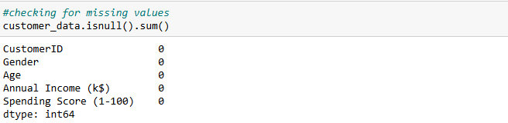

- STEP-3: Select only features of interest & remove remaining cols: Annual Income and Spending Score.

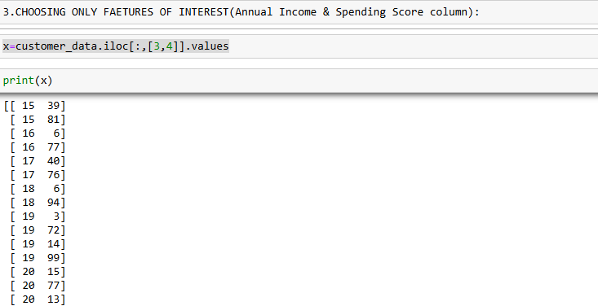

- Only the relevant features required for customer segmentation were selected from the dataset.
- The columns Annual Income and Spending Score were chosen as they best represent a customer’s purchasing capacity and spending behavior. These two features play a key role in identifying meaningful customer segments.
- Using Pandas’ iloc method, the selected columns were extracted and stored in a variable for further analysis and model training.

4. Optimum Number of Clusters (Elbow Method):
- Use Within-Cluster Sum of Squares (WCSS) formula shown in the diagram:
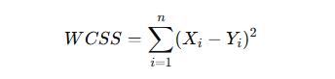

- Compute WCSS for different k values (e.g., 1–10).
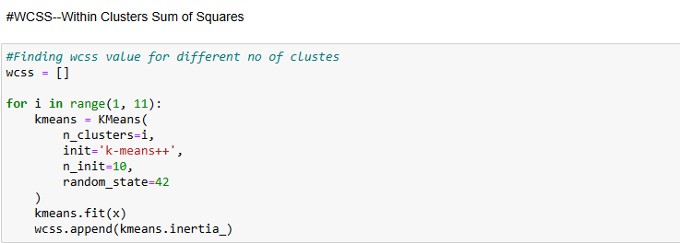

- Plot Elbow Curve → find the "elbow point" where reduction in WCSS slows down → gives optimal number of clusters.
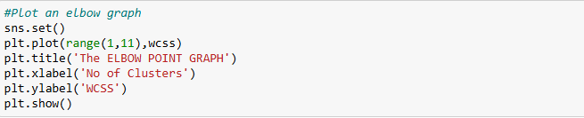
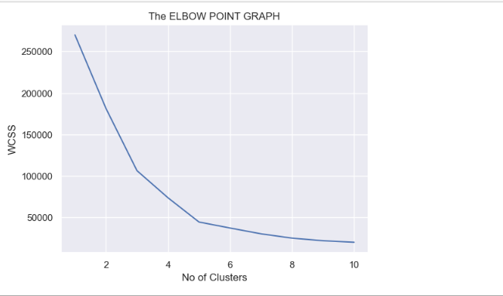

From this we get Optimum No of Clusters: 5

5. K-Means Clustering:

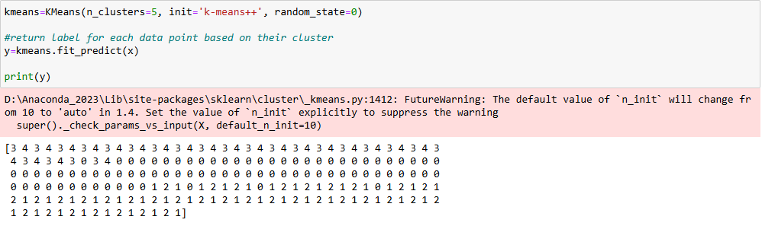
- Apply K-Means algorithm with chosen k.
- Assign each customer to a cluster based on similarity of income & spending.
- Each cluster represents a distinct customer group (e.g., high income–high spenders, low income–low spenders, etc.).

6. Visualizing the Clusters:

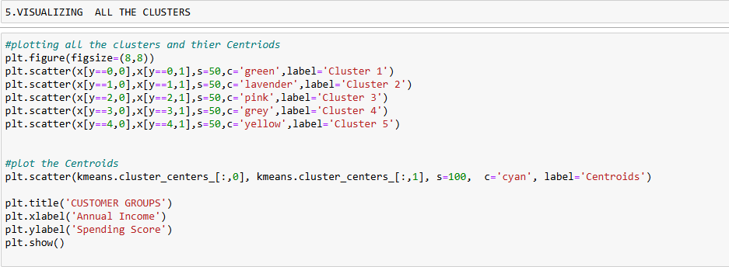

- Plot clusters in a 2D scatter plot (Annual Income vs Spending Score).
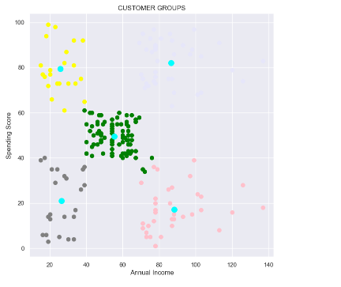

- Each cluster shown with a different color.
- Helps clearly interpret customer groups.

🔹 Business Insights from Segmentation:
- High income–high spenders → premium customers, target with luxury offers.
- Low income–low spenders → budget customers, target with discounts.
- High income–low spenders → potential customers, may need better engagement.
- Moderate income–average spenders → steady customers, upselling opportunities.

